Name_____________________________________

School ____________________________________

Class _____________________________________

Age ______________________________________

I have a family ___________

I have a ______________ _________________

______________________

I live in _________

I am ____________

All about me

I like _______

___________

I don’t like _____

________

_____________

My hobby is ________

__________________

I was born _______

________________

I am ________ by horoscope

Information about myself

It is ................ that/who wakes me up in the morning.

When I get up in the morning I hate (like, prefer, enjoy) ………..

………………………………………………………….

When' I wake up I jump (crawl, slide, roll) out of bed because ………………………………………………………….

For breakfast I usually have a light (big, square, substantial) meal as ...................................................................................................

I hate (like, enjoy) going to school because ……………………………………………………………................................................................................................

After school I either ...................... or .......................................

When I come from school my parents always (never, often, sometimes) ask me about ................................................................................

Before doing my homework I .......................................................

I enjoy doing .............................................................................

I am not keen on doing .................................................................

After I do (have done) my homework I ......................................

If my friends come to see me ......................................................

If I go out on weekdays .............................................................

On weekends I usually have a lie-in (get up at the usual time) because ......................................................................................

As soon as my head touches the pillow I .......................................

 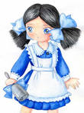

My family tree

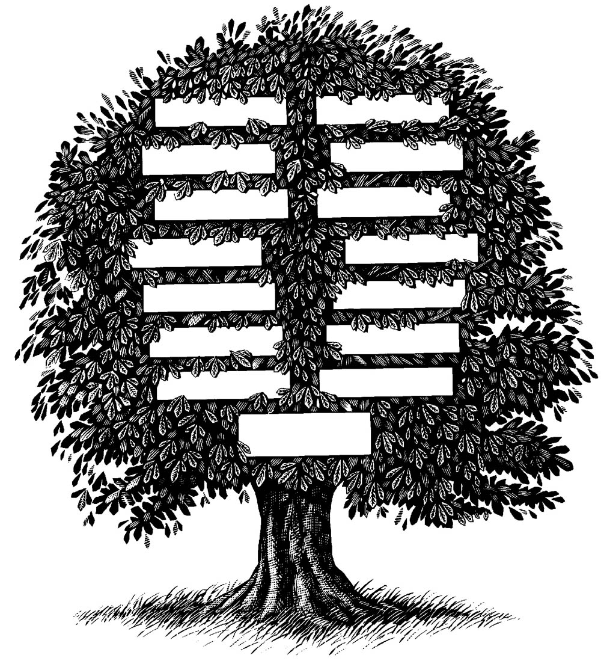

I and my friend

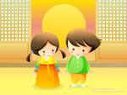

* My friend is always straight with me
* My friend is always ready to give me a helping hand
* I can always rely on my friend
* I can have a good laugh with my friend
* I can share my secrets with my friend
* My friend always cares about me
* My friend always cheers me up when I am depressed
* I can trust my friend
* My friend doesn’t demand too much of me
* I can ask my friend to support and advice
* I feel safe with my friend

[**A friend in need is a friend indeed**](http://www.sky-net-eye.com/rus/english/proverbs/A_p/A-friend-in-need-is-a-friend-indeed)

* A friend is a person with whom I may be sincere. Before him I may think aloud.
* Friendship cannot stand always on one side.
* Between friends all is common.
* It is a true saying that a man must eat a peck of salt with his friend, before he knows him.

The ideal friend

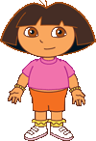

Pleasant; a kind face; a charming smile; straight and short hair; turned up nose; fashionable clothes;

Cheerful; shy; sociable; active; kind – hearted;

C:\Users\Таня\Desktop\img006.gif

I and my friend

I am good at ……….

My friend is good at………….

I often ask my friend for advice because

………………………………..

My friend often asks me for advice because ……………………….

If I am wrong my friend ………….

…………………………………

If my friend is wrong I ……………

……………………………….

UNIT 1. Introduction. I and my friend.

Listening

|  |  |  |  |
| --- | --- | --- | --- |
| № | I can understand | Yes | No |
| 1 | I can recognize words and sentences and I know what they mean |  |  |
| 2 | I can understand the teachers short instructions |  |  |
| 3 | I can understand short dialogues at a faster speech |  |  |
| 4 | I can understand speech at a normal speed on subject I have learned about |  |  |
|  |  |  |  |
|  |  |  |  |

Speaking

|  |  |  |  |
| --- | --- | --- | --- |
|  | I can | Yes | No |
| 1 | I can make myself understood by using some gestures and some words describing people’s appearance |  |  |
| 2 | I can describe my friend |  |  |
| 3 | I can say what features of character I look for in my best friend |  |  |
| 4 | I can agree or disagree with my friends ideas |  |  |
| 5 | I can take part in a short conversation of about 2-3 sentences |  |  |
| 6 | I can start and develop a conversation, give my opinions and ask questions of others |  |  |

Reading

|  |  |  |  |
| --- | --- | --- | --- |
|  | I can read | Yes | No |
| 1 | I can read and understand the words and word – combinations which we have practiced |  |  |
| 2 | I can read and understand short texts and dialogues about features of character |  |  |
| 3 | I can read and short texts and dialogues which the teacher has already read aloud to me and can use clues to guess the meaning of new words |  |  |

Writing

|  |  |  |  |
| --- | --- | --- | --- |
|  | I can write | Yes | No |
| 1 | I can write all new words and word – combinations which we have learned |  |  |
| 2 | I can write sentences with new words |  |  |
| 3 | I can I can write a list of questions I would like to ask my friend |  |  |
| 4 | I can write a short dialogue |  |  |
| 5 | I can write a short story on the topic “ My best friend” |  |  |
| 6 | I can a few sentences about my new friend I got acquainted with |  |  |

Holidays, Holidays …………

 Christmas in Britain

[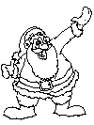](http://www.coloring.ws/t/christmas/89.htm) Santa Claus

[](http://www.coloring.ws/t/christmas/3.htm) a bag of toys

[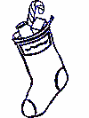](http://www.coloring.ws/t/christmas/24.htm) a Christmas stocking

[](http://www.coloring.ws/t/christmas/wreath1.htm) a Christmas wreath

[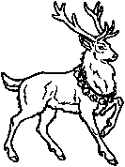](http://www.12days.com/library/coloringbook/deer4.htm) a reindeer

[](http://clipart.christiansunite.com/1103402460/Christmas_Clipart/Gifts_Clipart/Gifts004.gif) presents (gifts)

[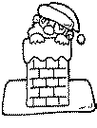](http://www.coloring.ws/t/christmas/santa2.htm) Santa Claus going down a chimney

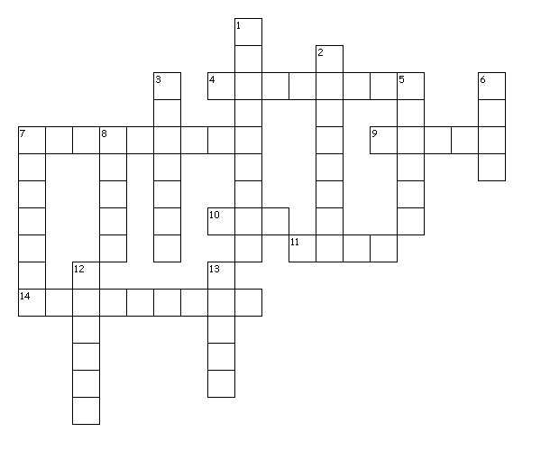Christmas crossword

**Across**

4. It means ‘gifts.’

7. Santa puts presents in children's ___.

9. It means happy.

10. Santa carries lots of toys in this.

11. Parents put presents under this.

14. Santa lives there.

**Down**

1. December 25th

2. They pull Santa's sleigh.

3. Santa goes down it.

5. Santa rides in this.

6. Children play with these.

7. Children make these when it snows.

8. Children eat candy ___.

12. People hang this on their doors.

13. They help Santa make toys.

Cut up these cards to use with the Christmas Game.

|  |  |  |
| --- | --- | --- |
| What colour is Santa's suit?  **Answer:** red | How does Santa get into the house?  **Answer:** down the chimney | What is Santa's favourite reindeer called?  **Answer:** Rudolph |
| What colour are Santa's boots?  **Answer:** black | What do children hang up for Santa to put the toys in?  **Answer:** a stocking (a sock) | If you are bad, what does Santa bring you for Christmas?  **Answer:** a piece of coal |
| What do the reindeer pull for Santa Claus?  **Answer:** a sleigh | How can you spell Christmas  with four letters?  **Answer:** X-mas | What bird do people in Britain and America usually eat for Christmas dinner?  **Answer:** a turkey or a goose |
| What are Christmas carols?  **Answer:** Christmas songs | What plant do you kiss under?  **Answer:** mistletoe | What plant with red berries are wreaths often made of?  **Answer:** holly |
| What night does Santa come?  **Answer:** December 24th  the night before Christmas | What does Santa carry in the sack on his back?  **Answer:** toys | Where does Santa live?  **Answer:** at the North Pole |
| Who helps Santa make toys?  **Answer:** the elves (one elf) | What do people often hang outside on their doors at Christmas?  **Answer:** a wreath | Where does Santa put the presents?  **Answer:**  under the Christmas tree |
| What do you call a man made of snow?  **Answer:** a snowman | What do you want for Christmas? | What do you usually do at Christmas? |

New Year





My family tradition



Easter

**Easter Religious**

**Hidden Message Word search**

J E S U S I S Y R I R S C S S

N S O U L E N A A E M B R U A

Z O H C R U H C T D S Y O S V

J K I H O L Y S W L N C S E I

G M F T D C A C M H R U S J O

O L B G C E E Y Y W O U S Y U

D U O T N E L L F R I D A Y R

M O G Y Q I R N E M L A P L T

D J A B L U D R N B J Q I Z I

F P J Q V J R L U B R Q I R A

M M N T Q E F M D S M A O L R

A I D Q U H U I Y B E A T U I

N O I X I F I C U R C R L E S

U T R F R T U R H Z C D W O E

P B C H P U Y Y G F V E F Q N

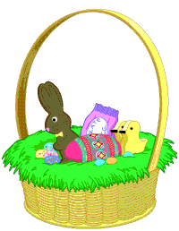

I can find all the words hidden in the Easter Word search Puzzle.

JESUS

LAMB

LENT

LILY

PALM

RESURRECTION

RISEN

SAVIOUR

SOUL

SUNDAY

CELEBRATE

CHURCH

CROSS

CRUCIFIXION

EASTER

FRIDAY

GOD

GOOD

HOLY

|  |  |
| --- | --- |
| valentinestitle |  |

The Valentine’s Day words below in the grid:

|  |  |  |  |  |  |
| --- | --- | --- | --- | --- | --- |
| valentines | | | | valentinedog | |
|  | cupidarrow | cherub with heart  Arrow  Be mine  Card  Chocolates  Cupid  Date  Flowers  Gift  Heart | Kiss  Love  Poem  Red  Ring  Romantic  Roses  Saint  Valentine | |

**Creative Writing**

**St. Valentine’s Day Poetry**

**Objective:** to teach learners how to write a cinquain poem and create a valentine

**Steps:**

1. Have the learners draw lines on a piece of paper as in the example below:

2. Have the Ss follow the steps below:

Write a Title:

Line 1: Write a noun

Line 2: Write two adjectives describing the noun on Line 1

Line 3: Write 3 words ending with ***-ing*** (action words) that describe what the noun

on Line 1 might do

Line 4: Write a phrase describing the noun on Line 1

Line 5: Write a synonym of the word on Line 1

**Example:**

**My Wonderful Valentine**

**Mother**

kind, helpful

caring, loving, sharing

a special person in my life

friend

**My Wonderful Valentine**

My favourite holiday

UNIT 2. Our favourite holidays.

Listening

|  |  |  |  |
| --- | --- | --- | --- |
| № | I can understand | Yes | No |
| 1 | I can recognize words and sentences and I know what they mean |  |  |
| 2 | I can understand the teachers short instructions |  |  |
| 3 | I can understand short dialogues at a faster speech |  |  |
| 4 | I can understand speech at a normal speed on subject I have learned about |  |  |
| 5 | I can understand the information during the discussion |  |  |
|  |  |  |  |

Speaking

|  |  |  |  |
| --- | --- | --- | --- |
|  | I can | Yes | No |
| 1 | I can talk about my family ties and family traditions |  |  |
| 2 | I can describe holidays |  |  |
| 3 | I can discuss the topic |  |  |
| 4 | I can agree or disagree with some ideas |  |  |
| 5 | I can take part in a short conversation of about 2-3 sentences |  |  |
| 6 | I can start and develop a conversation, give my opinions and ask questions of others |  |  |

Reading

|  |  |  |  |
| --- | --- | --- | --- |
|  | I can read | Yes | No |
| 1 | I can read and understand the words and word – combinations which we have practiced |  |  |
| 2 | I can read and understand short texts and dialogues about features of character |  |  |
| 3 | I can read and short texts and dialogues which the teacher has already read aloud to me and can use clues to guess the meaning of new words |  |  |

Writing

|  |  |  |  |
| --- | --- | --- | --- |
|  | I can write | Yes | No |
| 1 | I can write all new words and word – combinations which we have learned |  |  |
| 2 | I can write sentences with new words |  |  |
| 3 | I can I can write a list of questions I would like to ask my friend |  |  |
| 4 | I can write a short dialogue |  |  |
| 5 | I can write a short story on the topic “ My best friend” |  |  |
| 6 | I can a few sentences about my new friend I got acquainted with |  |  |

Healthy lifestyle



 

**Healthy food**

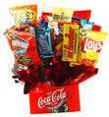 

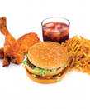

Unhealthy food

My recipe

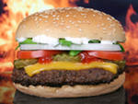

**Swiss Burgers**

**Ingredients:**

* 1 to 1 1/4 pounds ground beef
* 1/2 teaspoon salt, or to taste
* 1/4 teaspoon pepper, or to taste
* 1/2 cup dill pickle slices
* 1/2 cup shredded Swiss cheese
* 4 split toasted buns

**Preparation:**

Mix ground beef with salt and pepper. Form into 8 1/4-inch-thick patties. Place pickles and cheese on four patties. Top with remaining four patties and seal the edges. Broil or grill until done to your liking.

Health highlights

How do you feel?





What should you do to be healthy?

* You should………



What shouldn’t you do

* You shouldn’t smoke
* You shouldn’t …….

UNIT 3. Healthy lifestyle.

Listening

|  |  |  |  |
| --- | --- | --- | --- |
| № | I can understand | Yes | No |
| 1 | I can recognize words and sentences and I know what they mean |  |  |
| 2 | I can understand the teachers short instructions |  |  |
| 3 | I can understand short dialogues at a faster speech |  |  |
| 4 | I can understand speech at a normal speed on subject I have learned about |  |  |
| 5 | I can understand the information during the discussion |  |  |
|  |  |  |  |

Speaking

|  |  |  |  |
| --- | --- | --- | --- |
|  | I can | Yes | No |
| 1 | I can talk about my family ties and family traditions |  |  |
| 2 | I can describe holidays |  |  |
| 3 | I can discuss the topic |  |  |
| 4 | I can agree or disagree with some ideas |  |  |
| 5 | I can take part in a short conversation of about 2-3 sentences |  |  |
| 6 | I can start and develop a conversation, give my opinions and ask questions of others |  |  |

Reading

|  |  |  |  |
| --- | --- | --- | --- |
|  | I can read | Yes | No |
| 1 | I can read and understand the words and word – combinations which we have practiced |  |  |
| 2 | I can read and understand short texts and dialogues about features of character |  |  |
| 3 | I can read and short texts and dialogues which the teacher has already read aloud to me and can use clues to guess the meaning of new words |  |  |

Writing

|  |  |  |  |
| --- | --- | --- | --- |
|  | I can write | Yes | No |
| 1 | I can write all new words and word – combinations which we have learned |  |  |
| 2 | I can write sentences with new words |  |  |
| 3 | I can I can write a list of questions I would like to ask my friend |  |  |
| 4 | I can write a short dialogue |  |  |
| 5 | I can write a short story on the topic “ My best friend” |  |  |
| 6 | I can a few sentences about my new friend I got acquainted with |  |  |

My leisure time



In my free time I ……………..

I prefer to spend my leisure time with ……………………………………….

I would like to go to …………………

My leisure time

To go to the theatre

To watch films

To read books

To visit the cinema

To play computer games

To play with my friends

My favourite film and cartoon

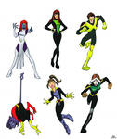

* Science fiction
* Drama
* Thriller
* Comedy
* Musical
* Western
* Adventure

My favourite actor

 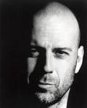

**Name:** Walter Bruce Willis

**Date of Birth:**  19 March 1955

**Place of Birth:**  Idar Oberstana, Germany

**First big movie:** Die Hard

**My favorite movie:** Sixth Sense

**Interesting facts:** father was American, mother was German. Studied at the college and then worked as a barman and played at the theatre.

Watching a performance



The children theatrical performance “Christmas” (review)

* The Chaparral Theatre, “Christmas”.
* The performance was impressive, unforgettable, remarkable…….
* The actors and actresses wore make-up and Christmas costumes. Their acting was enchanting and moving. They song a lot of Christmas carols and songs.
* The audience broke into applause and the spectators stood up. All people e enjoyed the performance greatly.
* The performance had a great success.

The Donetsk national dramatic theatre

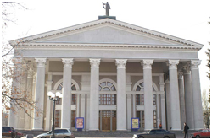

* Was opened in 1933 in Donetsk
* The first performance was musical “ Natalka Poltavka”.
* During the Second World War a lot of actors went to the front and defended our Motherland.
* Nowadays the Donetsk national theatre is one of the famous theatres in Ukraine. It was awarded the National Prize by the name of Taras Shevchenko in 2003.
* It is a unique theatrical complex with five stages. The technical equipment of the stages corresponds to all the modern standards.
* The Theatre performs the modern and historical plays.
* I 2001 it was assigned the rank of Academic National Theatre.

UNIT 4. The world of cinema and theatre.

Listening

|  |  |  |  |
| --- | --- | --- | --- |
| № | I can understand | Yes | No |
| 1 | I can recognize words and sentences and I know what they mean |  |  |
| 2 | I can understand the teachers short instructions |  |  |
| 3 | I can understand short dialogues at a faster speech |  |  |
| 4 | I can understand speech at a normal speed on subject I have learned about |  |  |
| 5 | I can understand the information during the discussion |  |  |
| 6 | I can understand the information during the presentation |  |  |

Speaking

|  |  |  |  |
| --- | --- | --- | --- |
|  | I can | Yes | No |
| 1 | I can talk about my favourite actor or actress |  |  |
| 2 | I can describe a cinema and a theatre buildings |  |  |
| 3 | I can talk about favourite films and performances |  |  |
| 4 | I can talk about going to the theatre and the actor’s play |  |  |
| 5 | I can express personal point of view |  |  |
| 6 | I can start and develop a conversation, give my opinions and ask questions of others |  |  |

Reading

|  |  |  |  |
| --- | --- | --- | --- |
|  | I can read | Yes | No |
| 1 | I can read and understand the words and word – combinations which we have practiced |  |  |
| 2 | I can read and understand short texts and dialogues |  |  |
| 3 | I can read short texts and dialogues which the teacher has already read aloud to me and can use clues to guess the meaning of new words |  |  |

Writing

|  |  |  |  |
| --- | --- | --- | --- |
|  | I can write | Yes | No |
| 1 | I can write all new words and word – combinations which we have learned |  |  |
| 2 | I can write sentences with new words |  |  |
| 3 | I can write a list of questions I would like to ask my friend |  |  |
| 4 | I can write a composition, use the correct linking words and phrases. |  |  |
| 5 | I can write a short story on the topic “ My favourite actor or actress” |  |  |
| 6 | I can write a theatrical performance review |  |  |

Focus on sport

Sport helps me to be healthy and cheerful!

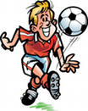 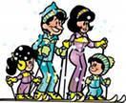

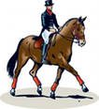I enjoy playing outdoor games with my friends.

All these things help people to keep fit

* Morning exercises
* Riding a long distances
* Going in for sports
* Eating healthy food

**Have fun.**

**Match the pictures and the names of the sports.**

|  |  |  |  |  |  |  |
| --- | --- | --- | --- | --- | --- | --- |
| 1 | 2 | 3 | 4 | 5 | 6 | 7 |
| 8 | 9 | 10 | SKIJUMP  11 | 12 | 13 | 14 |
| 15 | 16 | 17 | 18 | 19 | 20 | DOWNHILL  21 |
| 22 | 23 | 24 | 25 | 26 | 27 | 28 |
| 29 | 30 | 31 | 32 | 33 | 34 |  |

|  |  |  |  |  |  |  |
| --- | --- | --- | --- | --- | --- | --- |
| **a**) jogging  **b)** boxing  **c)** ski jumping  **d)** hand-gliding  **e**) body-building | **f)** diving  **g)** cycling  **h)** fishing  **i)** badminton  **j)** speed skating | **k)** rugby  **l)** weight lifting  **m)** golf  **n)** yoga  **o)** sailing | **p)** rhythmic gymnastics  **q)** rock  climbing  **r)** wind-surfing  **s)** soccer  **t)** sumo | **u)** skateboarding  **v)** tennis  **w)** karate  **x)** hiking  **y)** cricket | **z)** pole vaulting  **aa)** American football  **bb)** long jumping  **cc)** equestrian sport  **dd)** downhill skating | **ee)** step aerobics  **ff)** muscle training  **gg)** skiing  **hh)** sprint |

**Indoor and outdoor sports**



Surfing

Ice hockey

Diving

Archery

Volleyball

Horse racing

Wrestling

Handball

Skating

Sailing

Bowling

Tennis



Popular kinds of sports in Ukraine

Boxing Football

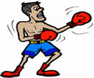 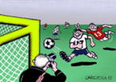

Figure skating Swimming

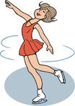 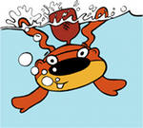

Sports Place Equipments

футбол2 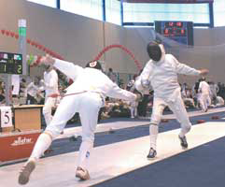 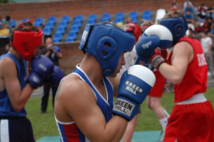  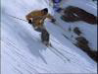 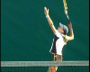  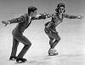

Football Rowing

Basketball Swimming

Tennis Fencing

Boxing Wrestling

Figure skating Athletics

Icy skating Surfing

Pitch River

Ring Alley

Slope Pool

Stadium Rink

Court

Rink

Boots Racket Costume

Glovers Hoop Tracksuit

Skis Boat Hockey Skate

Ball Oar rod

My favourite sportsman

[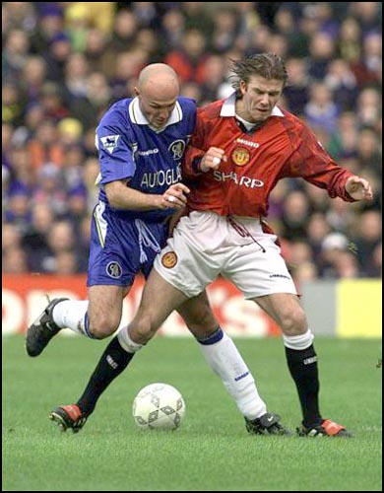](http://images.mm52.com/occidentalidols/devid_beckham/devid_beckham_008.jpg) **Name: David Beckham**

**[Click Here! View actual size David Beckham Picture . If you never see this picture, Please press [F5] KEY to Refresh It.](http://images.mm52.com/occidentalidols/devid_beckham/devid_beckham_008.jpg) Date of Birth: 2 May 1975**

**Place of Birth: London, England**

**Zodiac sign: Taurus**

**Home: Madrid**

**Wife: Victoria Adams**

**Children: Brooklyn and Romeo**

**Team: Real Madrid**

**Interesting facts: He collects cars and likes to change his image**

UNIT 5. Focus on sports.

Listening

|  |  |  |  |
| --- | --- | --- | --- |
| № | I can understand | Yes | No |
| 1 | I can recognize words and sentences and I know what they mean |  |  |
| 2 | I can understand the teachers short instructions |  |  |
| 3 | I can understand short dialogues at a faster speech |  |  |
| 4 | I can understand speech at a normal speed on subject I have learned about |  |  |
| 5 | I can understand short conversations and radio programme on the topic |  |  |
| 6 | I can understand the information during the presentation |  |  |

Speaking

|  |  |  |  |
| --- | --- | --- | --- |
|  | I can | Yes | No |
| 1 | I can talk about my favourite sportsman |  |  |
| 2 | I can describe people, features of characters, feelings, sports equipment and events |  |  |
| 3 | I can talk about the role of sport in our life and different kinds of sports |  |  |
| 4 | I can talk about my favourite kinds of sport and my sports training |  |  |
| 5 | I can express personal point of view |  |  |
| 6 | I can start and develop a conversation, give my opinions and ask questions while doing a survey and present information about events and facts |  |  |

Reading

|  |  |  |  |
| --- | --- | --- | --- |
|  | I can read | Yes | No |
| 1 | I can read and understand the words and word – combinations which we have practiced |  |  |
| 2 | I can read and understand short texts and dialogues |  |  |
| 3 | I can read short texts and dialogues which the teacher has already read aloud to me and can use clues to guess the meaning of new words |  |  |
| 4 | I can find relevant and necessary information in the texts |  |  |

Writing

|  |  |  |  |
| --- | --- | --- | --- |
|  | I can write | Yes | No |
| 1 | I can write all new words and word – combinations which we have learned |  |  |
| 2 | I can write sentences with new words |  |  |
| 3 | I can write a list of questions I would like to ask my friend |  |  |
| 4 | I can write a story based on a personal experience |  |  |
| 5 | I can write a short story on the topic “ My favourite sportsman ” |  |  |
| 6 | I can write a report about a sporting event |  |  |

**Teacher’s evaluation**

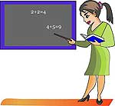

|  |  |  |
| --- | --- | --- |
| 1 | UNIT 1. Introduction. I and my friend. |  |
| 2 | UNIT 2. Our favourite holidays. |  |
| 3 | UNIT 3. Healthy lifestyle. |  |
| 4 | UNIT 4. The world of cinema and theatre. |  |
| 5 | UNIT 5. Focus onsports. |  |
|  |  |  |

My self - esteem



|  |  |  |
| --- | --- | --- |
| 1 |  |  |
| 2 |  |  |
| 3 |  |  |
| 4 |  |  |
| 5 |  |  |
| 6 |  |  |
|  |  |  |
|  |  |  |
|  |  |  |

***My Dossier***



My Projects

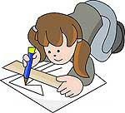

What I know and can do in languages

_______________________________________________________________________________________________________________________________________________________________________________________________________________________________________________________________________________________________________________________________________________________________________________________________________________________________________

My achievements

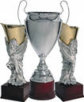

__________________________________________________________________________________________________________________________________________________________________________________________________________________________________________________________________________________________

My motto



Small steps,

Big results